Curriculum Information – Year 5 & 6 – Autumn 1

Class Text  ‘Skellig’ by David Almond | ‘Skellig’ by David Almond  Michael steps into the crumbling garage. What is this thing beneath the spiders’ webs and dead flies? A human being, or a strange kind of beast never seen before? The only person Michael can confide in is Mina. Together, they carry the creature into the light, and Michael’s world changes for ever…  Dealing with themes of friendship, healing and a belief in the impossible, Skellig’s true nature will open some challenging debates in class this half term and close reading of David Almond’s powerful text will enrich our very own writing.  We will be using our class text to help us with reading comprehension and inference in our guided reading sessions. | 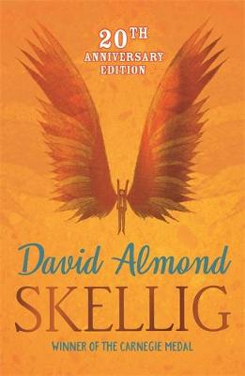
  RE | Creation and Covenant  This term in RE, we will be learning about Creation and Covenant. We will explore the story of Moses, including his encounter with God at the Burning Bush and the covenant God made with His people at Mount Sinai.  We will learn about the Ten Commandments and think about how God’s guidance helps people to make good choices, live happily and treat others with kindness, fairness and respect. We will also discover how Jesus summarised the commandments by teaching us to love God and love our neighbours.  As we continue our learning, we will explore what a covenant means, and how promises and commitment are important in our relationship with God and with others. We will also learn about sin, forgiveness and the Sacrament of Reconciliation, considering how relationships can be repaired when things go wrong.  Finally, we will think about virtues – positive habits such as honesty, compassion, generosity and justice – and how practising these can help us to become the best people we can be and better neighbours to those around us.  Throughout the term, children will have opportunities to ask questions, reflect, discuss their ideas and consider how their learning connects to everyday life. | 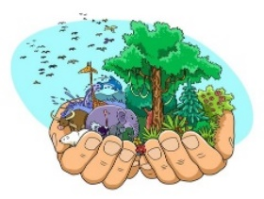  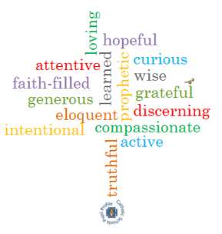  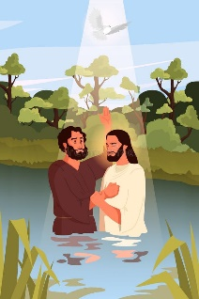
English   | Skellig  - Build tension, using techniques used by the author such as short sentences, questions, negative adjectives and maintaining anonymity.  - Plan a meal that would truly delight Skellig, using what we know about his eating habits.  - Write a poem, communicating Skellig’s character, through his possessions.  - Write a discursive report, on a chosen topic, examining both sides of the argument.  - Grammar focus: figurative language, adjectives, adverbs, short sentences, rhetorical questions, punctuation.  - Focus on spellings: National Curriculum Y3/4 and Y5/6 lists.  - Guided reading texts: ‘Skellig’ by David Almond.
Maths   | Year 5 (Textbook A):  - Unit 1: Place Value within 1,000,000 (1)  - Unit 2: Place Value within 1,000,000 (2)  - Unit 3: Addition and Subtraction  - Unit 4: Multiplication and Division (1)  Year 6 (Textbook A):  - Unit 1: Place Value within 10,000,000  - Unit 2: Four Operations (1)  - Unit 3: Four Operations (2)  - Unit 4: Fractions (1)
  Science | Forces  Do forces all rely on solid contact?  - Explain that unsupported objects fall towards the Earth because of the force of gravity acting between the Earth and the falling object.  - Identify the effects of air resistance, water resistance and friction that act between moving surfaces.  - Recognise that some mechanisms, including levers, pulleys and gears, allow a smaller force to have a greater effect. |   
History   | The Mayas  Why are the Mayas remembered today?  - Describe events from the past using dates when things happened.  - Know how an event/events from the past have shaped our lives today.  - Know how to draw a timeline with different historical periods showing key historical events or lives of significant people. | 
Computing   | Unit 5.1: Coding  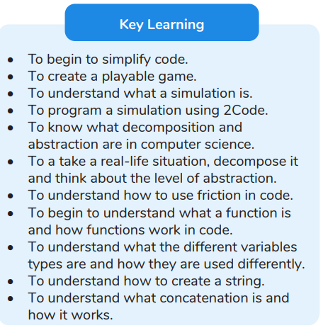  Unit 5.2: Online Safety  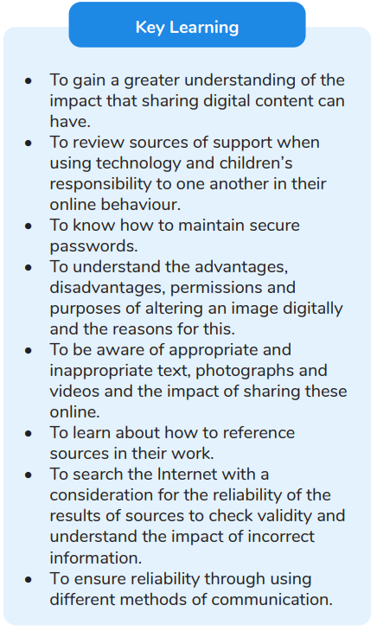 | 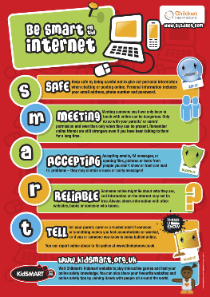  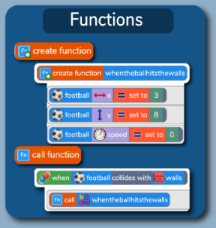
French   | Portraits – Describing in French  - Identify rhyming words and the same phonemes in different words.  - Listen for specific words and phrases.  - Apply language detective strategies such as use of cognates to work out meaning.  - Understand how the gender and number of a noun modifies adjectives.  - Explain where to place different types of adjectives in relation to the noun.  - Use familiar language to speak in sentences.  - Attempt to build accurately-written sentences using a model. | 
  Music | Music  - Music will be taught by Mrs Amison on a weekly basis.  - Music lessons will take place on Tuesdays.  - Whole school hymn practice will also take place on Tuesdays. | 
PE | This half term Year 5/6 will be swimming on Monday afternoons. Please ensure your child has the correct swimming uniform.
PHSE   | Being Me In My World  Am I One in a Million?  - I can face new challenges positively and know how to set personal goals.  - I understand my rights and responsibilities as a British citizen and as a member of my school. I can make choices about my own behaviour because I understand how rewards and consequences feel.  RSHE  - We will be following the Ten:Ten ‘Life to the Full’ programme for RHSE. Please log into the parent portal to access information about the programme your children will be following, as well as resources and suggestions for further activities at home.  - You will need the following login credentials for our school:  Username: st-mary-st6  Password: vision24-st6 | 
Homework | Daily Homework  - Children in Year 5 & 6 receive daily maths homework that will enable them to practise the 4 basic operations as well as apply these to reasoning questions.  - Daily literacy homework will focus on spelling, vocabulary and grammar.  Weekly Homework  - Each week, two pieces of homework are set for the children to complete (no more than 30 minutes each piece).  - Homework may be revision from a unit of work previously taught or it may be new learning for a unit or concept that will be followed up in class.  - All children will receive a piece of Maths or English each week (this will take no longer than 30 minutes to complete). They will also receive one piece from either RE, Science, History, Geography, Art, DT, French, Computing, PE or PSHE (these subjects will be rotated on a weekly basis).  - Homework is handed out on a Thursday and due in the following Tuesday.  Reading Diaries  - Children are encouraged to read at home daily (for at least 20 minutes) and are expected to have their diaries signed by an adult at least 3 times a week.  Spellings  - It is extremely important that spellings are practised regularly at home. The children are to use the Year 3/4 and 5/6 National Curriculum spelling guides.  Mental Maths/Times Tables  - Times tables and mental maths skills are vital for your child’s progress in maths. These should be practised regularly.  - Please encourage your child to practise their times tables using our ’99 Club’ resources on our school website.  - TTRS is a great platform to practise times tables regularly, whilst having fun too!
Thank You   | We would like to thank you for your support. If you have any questions then please do not hesitate to contact the Year 5/6 team via the office.  Mrs Edwards & Mrs Zoumides

