Curriculum Information – Year 5 & 6 – Autumn 2

Class Text | ‘Harry Potter and the Philosopher’s Stone’  Our class text this half term is ‘Harry Potter and the Philosopher’s Stone’ by J.K. Rowling.  Harry Potter thinks he is an ordinary boy – until he is rescued by a beetle-eyed giant of a man, enrols at Hogwarts School of Witchcraft and Wizardry, learns to play Quidditch and does battle in a deadly duel. The reason: HARRY POTTER IS A WIZARD! | 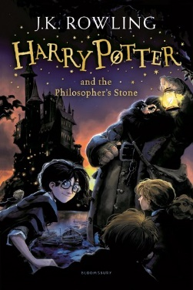
  RE | Followers of Christ  In this unit of work we consider the call of the disciples by Jesus. The children will learn about the demands that the call of Christ placed on these first disciples and they will think about ways in which people answer the call of Christ today through the life of the Church.  Advent  - Understand the two parts of the season of Advent.  - A time to prepare for Christ to come again and a time to prepare to celebrate his birth at Christmas. | 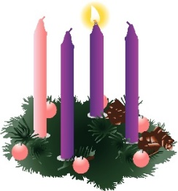  
English   | - Write a persuasive letter.  - Write a non-chronological report.  - Use imaginative description to write a narrative.  - Grammar focus: informal language, direct speech, first person, descriptive language, apostrophes, tense, subheadings, headings, coordinating conjunctions, subordinating conjunctions, modal verbs, relative clauses, figurative language.  - Focus on spellings: National Curriculum Y3/4 and Y5/6 lists.
Maths  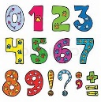 | Textbook A (Year 5)  - Multiplication and Division  - Fractions  Textbook A (Year 6)  - Four Operations  - Fractions  - Measure – Imperial and Metric Measures
Science | Could you be the next X-box apprentice?  - Associate the brightness of a lamp or the volume of a buzzer with the number and voltage of cells used in a circuit.  - Compare and give reasons for how components function (brightness of bulbs, loudness of buzzers).  - Know and use correct circuit symbols in a diagram.
Geography   | What are biomes?  - Know what is meant by biomes and what the features of a specific biome are.  - Label the layers of a rainforest and know what deforestation is.  - Know how to use graphs to record features such as temperature or rainfall across the world. | 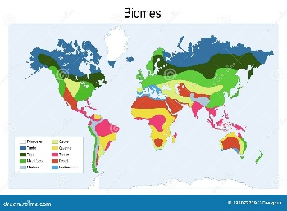
Design and Technology   | How can I adapt my pizza recipe for purpose?  · Suggest some alternative designs and compare the benefits and drawbacks to inform the design process and outcome.  · Children to adapt plans based on obstacles that arise in creation  · Children to self-assess and peer assess each other's work and produce a basic evaluation with guidance.  · Begin to understand seasonality of foods.  · Understand food can be grown, reared or caught in the UK and the wider world.  · Describe how recipes can be adapted to change appearance, taste, texture, aroma.  · Use range of techniques such as mixing, kneading, rolling and baking.  · Prepare and cook a seasonal dish safely and hygienically.  · Accurately weigh, measure and combine ingredients.  · To independently put safety and hygienic methods into practice.  · Present product well - interesting, attractive, fit for purpose.
Computing   | Online safety  - To identify benefits and risks of mobile devices broadcasting the location of the user/device.  • To identify secure sites by looking for privacy seals of approval.  • To identify the benefits and risks of giving personal information.  • To review the meaning of a digital footprint.  • To have a clear idea of appropriate online behaviour.  • To begin to understand how information online can persist.  • To understand the importance of balancing game and screen time with other parts of their lives.  • To identify the positive and negative influences of technology on health and the environment.  Presenting with Microsoft Powerpoint  • To understand the uses of PowerPoint.  • To create a page in a presentation.  • To add media to a presentation.  • To add animations to a presentation.  • To add timings to a presentation.  • To use the skills learnt to design and create an engaging presentation.
French  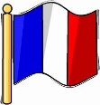 | Francais – In My French Home  J’habite dans…  - Understand the French words for different types of houses and their rooms.  - Ask and answer questions using vocabulary about houses and rooms.  - Remember and understand the elements of a house.  - Use a writing frame to create a written description of a house.  - Label things in a bedroom and use the related vocabulary in a sentence.
PE  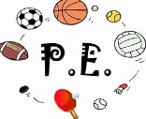 | PE  - This half term, children in Year 5 & 6 will have PE lessons on Mondays and Thursdays  - Please ensure that your child has their PE kit in school on these days for indoor and outdoor weather.
  Music | Music  - Music will be taught by Mrs Amison on a weekly basis.  - Music lessons will take place on Tuesdays.  - Whole school hymn practice will also take place on Tuesdays. | 
PHSE   | Celebrating Difference (Year 5)  - I understand that cultural differences sometimes cause conflict.  - I understand what racism is.  - I understand how rumour-spreading and name-calling can be bullying behaviours.  - I can explain the difference between direct and indirect types of bullying.  - I can compare my life with people in the developing world.  - I can understand a different culture from my own.  Celebrating Difference (Year 6)  - I understand there are different perceptions about what normal means.  - I understand how being different could affect someone’s life.  - I can explain some of the ways in which one person or a group can have power over another.  - I know some of the reasons why people use bullying behaviours.  - I can give examples of people with disabilities who lead amazing lives.  - I can explain ways in which difference can be a source of conflict and a cause for celebration.  RSHE  - We will be following the Ten:Ten ‘Life to the Full’ programme for RHSE. Please log into the parent portal to access information about the programme your children will be following, as well as resources and suggestions for further activities at home.  - You will need the following login credentials for our school:  Username: st-mary-st6  Password: vision24-st6 | 
Homework | Daily Homework  - Children in Year 5 & 6 receive daily maths homework that will enable them to practise the 4 basic operations as well as apply these to reasoning questions.  - Daily literacy homework will focus on spelling, vocabulary and grammar.  Weekly Homework  - Each week, two pieces of homework are set for the children to complete (no more than 30 minutes each piece).  - Homework may be revision from a unit of work previously taught or it may be new learning for a unit or concept that will be followed up in class.  - All children will receive a piece of Maths or English each week (this will take no longer than 30 minutes to complete). They will also receive one piece from either Science, History, Geography, Art, DT, French, Computing, PE or PSHE (these subjects will be rotated on a weekly basis).  - Homework is handed out on a Thursday and due in the following Tuesday.  Reading Diaries  - Children are encouraged to read at home daily (for at least 20 minutes) and are expected to have their diaries signed by an adult at least 3 times a week.  Spellings  - It is extremely important that spellings are practised regularly at home. The children are to use the Year 3/4 and 5/6 National Curriculum spelling guides.  Mental Maths/Times Tables  - Times tables and mental maths skills are vital for your child’s progress in maths. These should be practised regularly.  - TTRS is a great platform to practise times tables regularly, whilst having fun too!
Thank You | We would like to thank you for your support. If you have any questions then please do not hesitate to contact Mrs Edwards via the office.  Mrs Edwards, Mrs Bates and Mrs Zoumides

