Curriculum Information – Foundation
Autumn 2 2025


Hello boys and girls! Welcome back to our Second half term of the school year! What a busy one this will be!

Our topic for this half term is ‘Into the Woods’. We are going to explore the season of autumn further, specifically looking at animals that hibernate. We will also be starting this half term looking at the celebration of Bonfire night, followed by the Celebration of the Festival of light, Diwali. We will explore both of these occasions and how they are celebrated by people in our world.
We also have an exciting half term as it will be the first time we will go onto the school trip together to visit someone special! This will lead us perfectly into the beginning of Christmas celebrations and of course our lovely Christmas Nativity!

In R.E we will explore the celebration of Baptism in our church. We will then move onto looking at the Advent in our lead up to Christmas day. During these next few weeks we will also look at Remembrance Day together as a class.

Don’t forget to send in all your family observations using the
‘Evidence Me’ app as we love to see what other learning experiences your child is experiencing.
A few points to remember:
We know it can be a big adjustment for both parents and children starting a new adventure at school. The children are becoming so confident coming into the classroom now and we feel like to bring their independence on a little more we would love for them to start coming in to the class in the morning all by themselves. We will be there on hand to help with coats and bags to start their day! We appreciate all of your support with this. Thank you – The Foundation Stage Team
- Please bring in book bags only – no backpacks where possible
- Please bring in wellies in for the children to keep in school
- Please bring in a water bottle for your child to have – please label
- It is really important that all clothing and belongings are labelled with your child’s name. This will avoid any items being lost.
TOY FUND! – Thank you so much already for all our fantastic donations to the toy fund! The children have enjoyed lots of messy play already within our continuous provision, exploring pumpkins, making potions, playdough and this half term we will be getting some more special books to add to our lovely reading area!

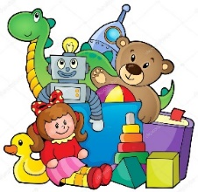
We love to keep resources nice and be able to buy resources when children have particular interests. We would like to ask for a donation of 50p a week for your child. This 50p would go towards new toys and learning resources for your children. This donation would be greatly appreciated if you are able to contribute. You can bring the 50p in weekly or if you would prefer to donate for the half term that is also fine.
Many thanks
The Foundation Stage Team
RE   | Our Class Saint – St Mary Mother of Jesus  Baptism  > We will look at this Special celebration and we will look closely at what happens during a Baptism and what this means in the Catholic Faith  Advent  > We will look closely at the time of Advent where we count down to the special meaning of Christmas and the Birth of Jesus. | 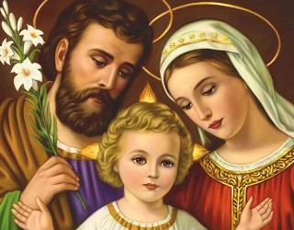
  Reading | Story focus  Owl Babies  Stick Man  The Nativity  Rhyme of the week  Autumn rhymes  Traditional rhymes  Number rhymes  Nursery: Phase 1- all aspects  Aspect 1 – General sound discrimination – environmental  Aspect 2 – General sound discrimination – instrumental sounds  Aspect 3 – General sound discrimination – body percussion  Aspect 4 – Rhythm and rhyme  Aspect 5 – Alliteration  Aspect 6 – Voice sounds.  Aspect 7 – Oral blending and segmenting  Bug Club – All Sorts of Art  Reception – Phase 2  Segmenting AND Blending words containing sounds that I recognise and know.  Recap – S,a,t,p,i,n,m,d,g,o  Teach – c,k,ck,e,u,r,h,b
  Writing | Nursery  To make marks freely and to talk about the marks I am making.  Reception  To write my name using the correct letter formation.
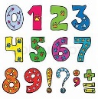  Maths | Nursery: Measure/shape and Spatial thinking  Reception: Change within 5, Number bonds to 5, Space/Spatial Awareness
  Understanding of the World | Diwali – Find out about Diwali  Christmas – To talk about significant events  Bonfire night – To talk about significant events | 
  Creative | > Autumn crafts  > Bonfire crafts  > Poppies  > Diwali – Diva lamps | 
PE   | Please bring in your P.E bag and ensure that ALL clothes are clearly labelled. P.E bags will remain in school and we will send them home at the end of each half term  FUNdamental Skills / Balance | 
Class Mascot  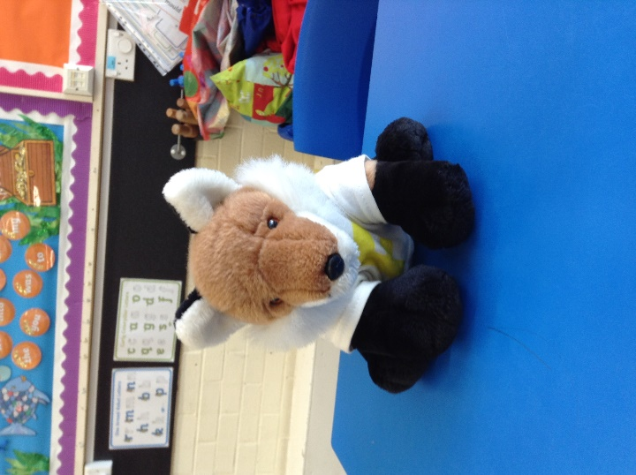 | Our class mascot is ‘Mr Brown Bear’!  Mr Brown Bear lives in our classroom and he loves to look out for children following our golden rules!  Anyone who achieves our Star of the Week will be able to take Mr Brown Bear home for the weekend. You can write down all the adventures you take him on during the weekend and you can also stick in pictures! | 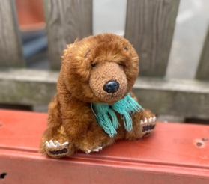  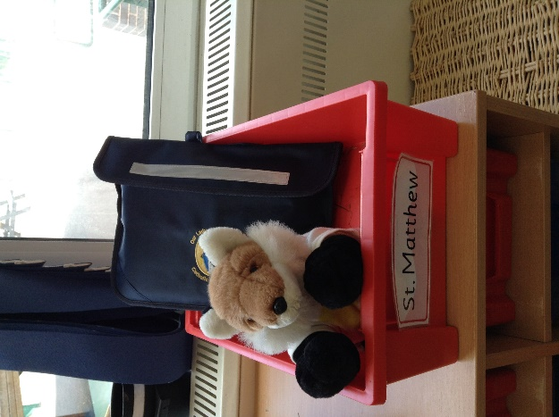
  Magic Moments | Please let us know of "Magic Moments" when you feel that your child has learnt anything new as this will allow us to provide next steps in their learning.  This can be sent to us through the Evidence Me APP | 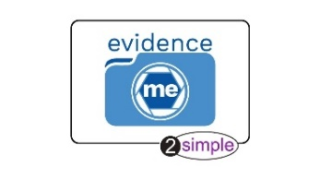
Class Target   | Whole Foundation Stage Target  To zip and unzip my coat and to hang it on my peg independently. | 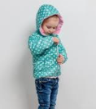
Reading  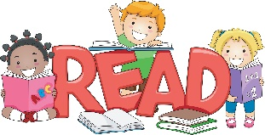 | Library books – Class library books will be changes weekly, on a Wednesday. Please put you library book in your book bag on a Wednesday to be changed.  Reading books – When the Nursery children have a reading book, this will be a picture book. Once this transition happens please try to take the time to read their school book 3x a week. This will help to prepare them for a reading routine throughout their time at Our Lady of Grace and further!  Reception: Please encourage children to segment and blend the sounds in each word to help them to decode it.  We also encourage reading of children’s favourite books, traditional tales and all other books they love! | 
Key events for the half term  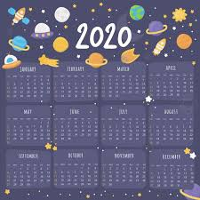 | Please see the school website / calendar for further information.

