Curriculum Information – Year One and Two – Autumn 1

Class text | To begin the year, our class text will be ‘The Princess and the Pea’ by Rachel Isadora. The children will be exploring the story, retelling it and writing diary entries linked to the experience of the Princess. | 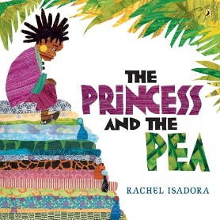
  RE | - We will begin this academic year by looking at Old Testament stories. This will give the children an insight into the stories and characters of the Old Testament.  - This unit will also introduce the children to some important images of God found in the scriptures. | 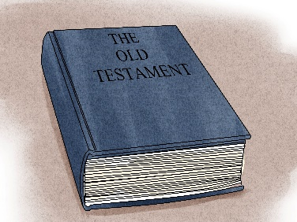  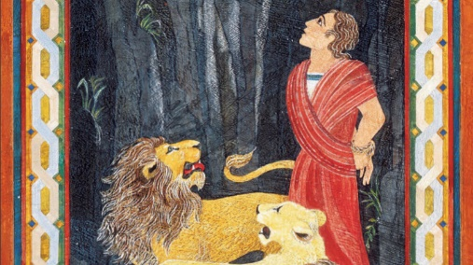
English   | All of our English learning this half term will be based on our class texts. Our first class text is ‘The Princess and the Pea’ by Rachel Isadora. We will then be moving on to ‘The Gingerbread Man’ and ‘Elmer’.  - Some of the grammar focuses for Y1 will be: Rearranging simple sentences into a coherent order, writing simple sentences from pictures, using phonics knowledge to write sentences, using the pronoun ‘I’ to write simple sentences, forming capital letters correctly, using full stops correctly, using adjectives, writing dictated sentences and questions.  - Some of the reading objectives that Y1 will be: Retrieving information from memory, pictures and text to answer comprehension questions and inferring how characters are feeling and what they are thinking using pictures.  - Some of the grammar focuses for Y2 will be: Using well-chosen adjectives to add detail, use expanded noun phrases, learn new spelling rules, writing, reviewing and improving, sentence types (including questions, statements, commands and exclamations), using nouns and pronouns for variety and using alternatives to ‘said’.  - Some of the reading objectives that Y2 will be focusing on: Using the text to retrieve information and developing ability to answer questions in full sentences and inferring what characters are thinking and feeling using the text.
Maths  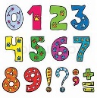 | This year we will be continuing our Power Maths journey. Mrs Pedley will be teaching Y1 for Maths and Mrs Davis and Mrs Clewes will be teaching Y2 for Maths. During the first half term, we will be focusing on the following objectives:  Y1:  - I can sort and group objects up to 10.  - I can identify ‘one more’ and ‘one less’ up to 10.  - I understand that two parts can make up a whole.  - I can use the Part-whole model within 10.  - I can add and subtract within 10.  Y2:  - I can count from 0-100 with confidence.  - I know ‘one more’ and ‘one less’ to 100.  - I can split numbers into ‘tens’ and ‘ones’ up to 100.  - I can add and subtract using a variety of methods, including fact families, partitioning and number bonds.
  Science | Would the North Pole be a suitable habitat for cactus?  - I can explore and compare living and non-living things (including things that have never been alive).  - I can describe how most living things (including plants) live in habitats or micro-habitats suited to them.  - I know that habitats provide for the basic needs of different animals and plants (and how they depend on each other). | 
  Geography | Would you have a BBQ in Winter?  - Know how the weather changes throughout the year and name the seasons.  - Know which is the hottest and coldest season in the UK.  - Keep a weather chart and answer questions about the weather.  - Know and recognise main weather symbols. | 
  Art | What is environmental art?  - Know how to use charcoal, pencil & pastel to create art.  - Know how to create tints with paint by adding white.  - Know how to create a piece of art in response to work of another artist.  - Know how to use a viewfinder to focus on a specific part of an artefact before drawing it. | 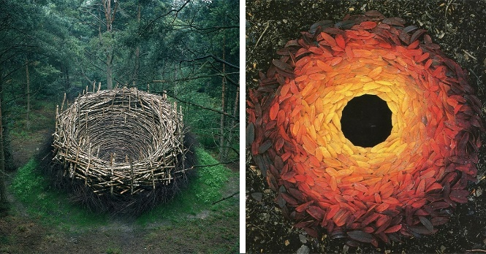
Computing   | What is online safety?  - Use technology purposefully to create, organise, store, manipulate and retrieve.  - Recognise common uses of information technology beyond school.  - Use technology safely and respectfully. | 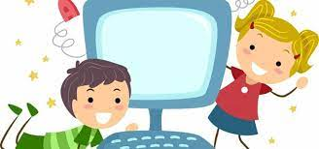
French  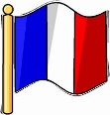 | - The children will be using their French phrases during the afternoon register.  - We will be learning lots of basic phrases for greetings. | 
PE  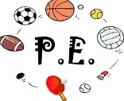 | - All Y1 and Y2 children will have Mr Sigley for PE on a Monday afternoon. A second PE lesson will take place on Wednesday afternoons, taught by Mrs Clewes.  - Please ensure your child’s PE kit is in school all week. They will be sent home at the end of each half term to be washed. | 
  Music | - Music continues to be taught by Mrs Amison on Tuesdays. | 
Key events for the half term | - 23rd and 24th Sept- Parent Teacher target meetings  - 29th September- St Gabriel the Archangel Launch Day  - KS1 Saint’s Day Assembly 3rd October 9:05am.  - Creation Day 3rd October  - 9th October- Phonics information sessions  - 10th October- Phonics Watch me Learn  - 17th October- RSE Parent Workshop
Homework | - Daily Maths homework will be four questions consolidating the week’s new maths learning. This must be completed by all children each evening.  - Daily Literacy homework. Y1 will bring home a word purse to support them with their phonics and fluency in reading. Please practice reading these words with your children each night. Y2 will be given a 5 words per week that may be linked to the class text or vocabulary from other curriculum areas. The children need to use these words within sentence and record this in their daily Literacy books.  - Weekly homework - Children will also receive one piece of homework on a Thursday to be returned on Monday. This homework will be centred around Science, History, Geography, D&T, Art, French, Computing or PSHE, and will be rotated on a weekly basis.  - Reading diaries – Children are encouraged to read at home daily (for at least 20 minutes) and are expected to have their diaries signed by an adult at least 3 times a week.  - For Y1, we change reading books twice a week (Monday and Thursday). The children will each receive one phonetically decodable book that they can read independently and one library book to encourage reading for pleasure.  - Y2 children will be able to change their book once they have taken an accelerated reader quiz. Children will be given login details and shown how to complete this in school. They will complete an online ‘Star Reader’ test at the beginning of the year and then termly to determine the book banding levels they need to read between.

