Curriculum Information – Year Three and Four – Autumn 2

Class text | Voices in the Park is rich in many layers of meaning and underlying concepts. Therefore, in reading, a clear focus upon inference will be key this half-term. During the last half term, children began to use inference in relation to the class text- this term we will attempt to expand this further. We will explore how perspective changes through the eyes of different characters and will construct autobiographies and a range of diary entries from the viewpoints of different characters. |  | 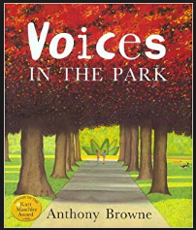  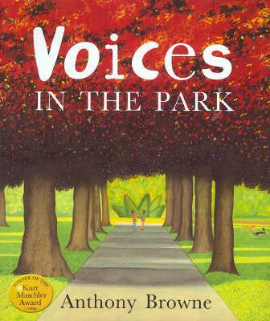
  RE | Sharing in the life of Christ: The Church as a Community  In this unit the children learn about the Universal Church  established on the original teaching of the Apostles. They  will reflect upon the Eucharist as the Sacrament which  celebrates the Church’s Unity. They will also be given  opportunities to find out about religious customs from  around the world.  Advent  Children will be able to place the first coming of Jesus in a historical context and learn of his ancestors. They will also study the role of the angels in the story of |  |   
English   | Our Literacy work will be based around Anthony Browne’s text, ‘Voices in the Park’. We will be looking closely at:  Non-chronological reports  • Diary entries  • Letters  • Balanced arguments/debates  • Poetry  • All of the above will be taught using the class text to support learning.  Grammar Focus/ Features of text type:  • Adjectives to describe nouns – expanded noun phrases  • Revisit er and est when formulating adjectives  • Explore similes (using ‘as’ and ‘like’)  • Form subordinate clauses using subordinating conjunctions  • Use of present perfect verb form  • Explore the language of comparison and contrast  • Turn notes into sentences grouping information  • Collect and use examples of prepositional phrases to clarify physical features.  • Form subordinate clauses using subordinating conjunctions  • Use of present perfect verb form  • Recap use of ‘a’ or ‘an’  • Use prepositions (during, in, because of, before, after),  • Use rhetorical questions.
Maths  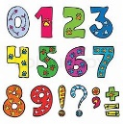 | - Power Maths Textbook A (Year 3)  - Addition and subtraction  - In this unit, children build on previous learning to add and subtract numbers with up to three digits. They begin by using place value equipment and formal written methods of column addition and subtraction.  - Multiplication and division  - This unit acts as a recap of children’s work in Year 2, where multiplication and division were introduced and equal and unequal groups were explored. It reminds children of the difference between equal sharing and equal grouping, as it is possible some children spent only a little amount of time on this. This unit provides essential preparation for their work on developing and securing multiplication knowledge.  Power Maths Textbook A (year 4)  - Measure – area  - This unit builds on children’s understanding of the properties of squares, rectangles and rectilinear shapes. It extends children’s basic comprehension of shapes being ’bigger’ or ’smaller’ than one another and gives them a tangible way of measuring this. Children already know how to measure the distance around a shape and now are taught how to measure the space inside it.  - Multiplication and division  - This unit builds upon the previous work children have done on multiplication and division from Year 3, where children learnt how to multiply by equal grouping and to divide using sharing. This unit also builds upon previous work children have done on addition and subtraction. It also develops children’s reasoning skills, which they are developing throughout the year.  Please continue to practise times tables at home regularly.
  Science | Sound  - In Science, we will recognise how sound is made and how it travels from a source.  - We will also explore what happens to a sound as it travels away from a source.  - Recognise the correlation between pitch and object producing a sound. |  | 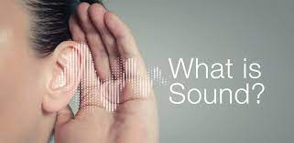
Geography   | The UK  Children will:  - Know the names of and locate at least eight European countries.  - Know the names of and locate at least eight counties and at least six cities in England.  - Know the names of four countries from the southern and four from the northern hemisphere |  | 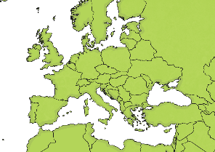
Art   | Storytelling through Drawing  Children will know:  - That we can tell stories through drawing & we can add text for meaning.  - That we can use line, shape, colour and composition to develop evocative and characterful imagery.  - That we can sequence drawings to help viewers respond to our story. |  | 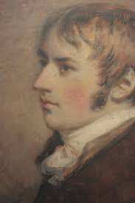
Computing   | Unit 4.4  Writing for Different Audiences  - In this unit, children learn that technology can be used to organise, reorganise, develop, and  explore ideas, and that working with information in this way can aid understanding. It also gives  children opportunities to discuss their experiences of using ICT and how it is used in the wider  World.  - Children will be able to apply what they have learnt in this unit when identifying key points  in a story or account, writing accounts in which details of character and action are used to interest  the reader and using evidence and examples to support key points. |  | 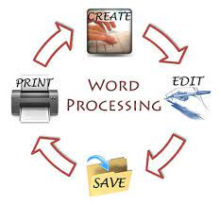
French   | The children will begin to learn and develop their French vocabulary further. They will have a variety of opportunities to practise their oracy, listening and writing skills in French and will be composing their own descriptive paragraphs, poems and stories to describe birthday celebrations.. |  | 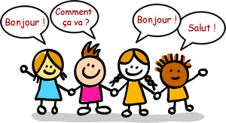
PE   | - This half term in P.E. we will be focusing on football and rugby with our PE specialist Mr. Sigley. |  | 
  Music | - Music continues to be taught by Mrs. Amison, every Tuesday. Year 3 and year 4 will be exploring families of orchestral instruments to create an ensemble piece! |  | 
Key events for the half term | - Watch me Learn 21/11/2025 Maths  - Family Mass 30/11/2025
Homework    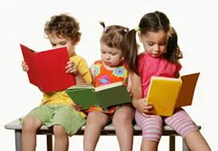 |  | - Daily Maths and Literacy set each day  - Two pieces of homework (Maths or English plus one foundation subject) will be handed out on a Thursday and should be completed and handed in on the following Monday.  - Times tables are tested on a Friday  Children also have logins to Times Table Rockstars and are expected to practise their times-tables weekly. Your child’s username & password will also be stuck in your child’s reading diary.  Home Reading  Reading helps children with their knowledge, understanding and language.  The children are taught to read in school however, it is important that you encourage your child to read at home daily. Children should read at home and have their reading diary signed by an adult at least 3 times a week.  It would be very much appreciated if you would talk to your children about their Accelerated Reader target and help them to achieve it by encouraging them to read as much as possible. Prizes for outstanding readers will also be given out in class!  Reading books will be changed frequently and every week the children will have the opportunity to choose a library book to read over the weekend.  Click the video link below for tips on how to support your child with reading at home.  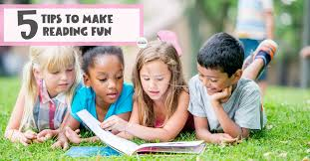  https://youtu.be/-OG2Q6pPQYw

