Curriculum Information – Year Three and Four – Autumn 1

Class text | Journey to Jo’burg – Beverly Naidoo  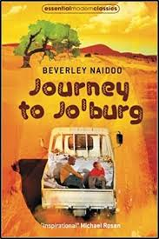
  RE | Creation and the story of Abraham to Joseph  Jesus teaches us how to pray  Creation and the story of Abraham to Joseph  - Know the stories of creation, Abraham and Isaac, Jacob and Joseph from the Old Testament.  - Understand from the story of creation that human beings are made in God’s image and likeness and that this needs to be valued and respected in other people.  - Identify how God called and protected both Abraham and Isaac.  Jesus teaches us how to pray  - Know that Jesus prayed to the Father and they will be able to identify some of the prayers that he learnt growing up in the Jewish faith.  - Explain why it is important to call and to pray to God the Father.  - Know some of the traditional prayers of the Church including the prayer of the Rosary. |   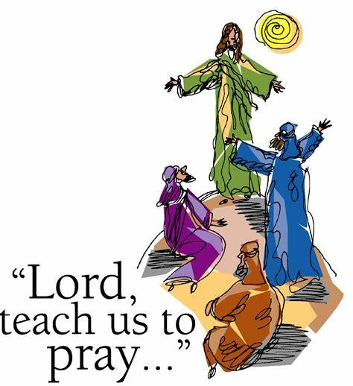
English   | Reading  - Listen and discuss a wide range of fiction, poetry, non-fiction and reference books or textbooks.  - Read books that are structured in different ways and reading for a range of purposes.  - Identify themes in books  - Recognise different forms of poetry.  - Discuss words and phrases which capture the readers imagination.  - Explain the meaning of words in context.  - Ask questions to improve their understanding  - Draw inferences from a text with evidence.  - Predict what might happen next.  - Identify the main ideas from more than one paragraph.  - Identify how language and structure contributes to meaning.  Writing  - Develop Expanded Noun phrases by using modifying adjectives, nouns and preposition phrases  - Use fronted adverbials  - Discuss writing similar to that which they are planning to write in order to understand and learn from its structure, vocabulary and grammar  - Discuss and record ideas for writing  - Begin to use paragraphs to group related material  - Use headings and subheadings to aid presentation  - In narratives, create settings, characters and plot  - In non-narrative material, using simple organisational devices such as headings and sub-headings  - Evaluate and edit by assessing the effectiveness of own and others’ writing and suggesting improvements  - Proof read for spelling and punctuation errors  - Read own writing aloud to a group or the whole class, using appropriate intonation and controlling the tone and volume so that the meaning is clear  - Use inverted commas and other punctuation for direct speech  - Apostrophes to show plural possession  - Use commas after fronted adverbials  Spelling  - Spell further homophones  - Spell words that are often misspelt see N/C  - Place the possessive apostrophe accurately in words with regular plurals (for example, girls’, boys’)  - Use the first 2 or 3 letters of a word to check its spelling in a dictionary  - Write from memory simple sentences, dictated by the teacher, that include words and punctuation taught so far  Handwriting  - Use the diagonal and horizontal strokes needed to join letters and understand which letters, when adjacent to one another, are best left unjoined  - Increase the legibility, consistency and quality of their handwriting  - Ensure downstrokes of letters are parallel and equidistant and lines of writing are spaced sufficiently so that the ascenders and descenders of letters do not touch
Maths  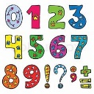   | Place Value  - Recognise the place value of each digit in a 4-digit number (1,000s, 100s, 10s, and 1s).  - Count in multiples of 6, 7, 9, 25 and 1,000.  - Identify, represent and estimate numbers using different representations.  - Find 1,000 more or less than a given number.  - Order and compare numbers beyond 1,000.  - Round any number to the nearest 10, 100 or 1,000.  Addition and Subtraction  - Add and subtract numbers with up to four digits using the formal written methods of columnar addition and subtraction where appropriate.  - Solve number and practical problems that involve addition and subtraction with increasingly large positive numbers.  - Estimate and use inverse operations to check answers to a calculation.  - Solve addition and subtraction two-step problems in contexts, deciding which operations and methods to use and why.  Click the links below to learn about place value of 3 digit numbers at home.  https://www.topmarks.co.uk/learning-to-count/place-value-basketball  https://www.topmarks.co.uk/place-value/place-value-charts  https://www.topmarks.co.uk/Flash.aspx?f=diennesandcoinsv3  Children also have logins to Times Table Rockstars and are expected to practise their times-tables weekly. Your child’s username & password is in the back your child’s reading diary.
  Science | How does electricity flow around a circuit?  Electricity  - Identify common appliances that run on electricity  - Construct a simple series circuit, identifying and naming its basic parts, including cells, wires, bulbs, switches and buzzers  - Identify whether or not a lamp will light in a simple series circuit, based on whether or not the lamp is part of a complete loop with a battery  - Recognise that a switch opens and closes a circuit and associate this with whether or not a lamp lights in a simple series circuit  - Recognise some common conductors and insulators, and associate metals with being good conductors  Working Scientifically  *Setting up simple comparative tests  Reporting on findings from enquiries, including oral and written explanations, displays or presentations of results and conclusions
History | What is the Iron Age?  - Know how Britain changed between the beginning of the stone age and the iron age  - Know the main differences between the stone, bronze and iron ages | 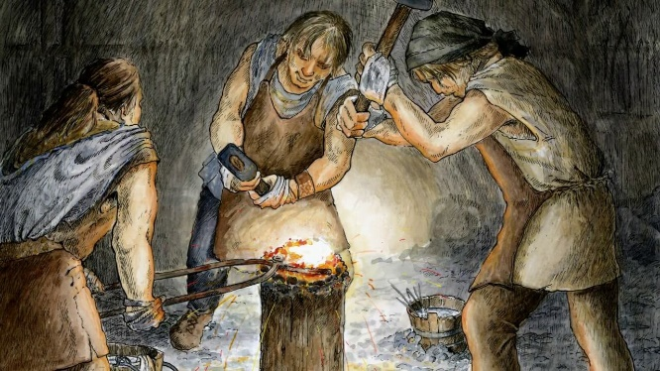
D & T   | How can I make my toy come to life?  Project outcome: Make a moving monster toy  - Make a product which uses mechanical components. (Levers and linkages) (Y3) | 
PSHE   | Being Me in My World  - Know my attitudes and actions make a difference to the class team.  - Understand who is in my school community, the roles they play and how I fit in.  - Understand how democracy works through the School Council.  - Understand that my actions affect myself and others; I care about other people’s feelings and try to empathise with them.  - Understand how groups come together to make decisions.  - Understand how democracy and having a voice benefits the school community. | 
Computing   | Unit: 3.4  Touch Typing  - To introduce typing terminology.  - To understand the correct way to sit at the keyboard.  - To learn how to use the home, top and bottom row keys.  - To practise typing with the left and right hand | 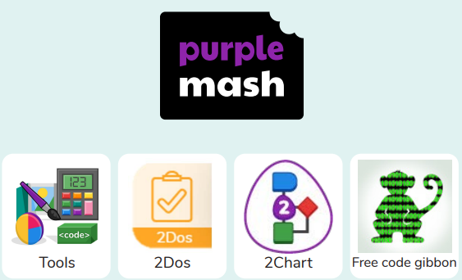
PE  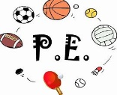 | PE will take place on Monday and Friday.  Invasion Games  - Use teaching points to keep the ball close & under control  - Use teaching points to pass effectively  - Use teaching points to shoot effectively  - Use knowledge of technique to suggest ways for peers to improve | 
  Music | Music continues to be taught by Mrs. Amison on a Tuesday morning.  Year 3  We will be exploring music that reflects the natural world, in particular, the animal kingdom. We will consider how a composer paints a musical picture and use similar techniques to make our own music describing an animal. We will also be singing together in a round and learning our first notes on the recorder.  Year 4  We will be exploring music that reflects the weather and the seasons, using works from a range of composers. We will review our rhythm and staff notation knowledge. We will be singing together using ostinato patterns and we will play our recorders, revising notes we learned in year 3. We will be learning how to make our first sounds and notes on our orchestral instruments. | 
French   | This is me  - Listening and responding to single words and short phrases.  - Asking and/or answering simple questions.  - Beginning to understand and notice cognates.  - Listening and repeating key phonemes with care.  - Recognising some familiar French words in written form.  - Writing some familiar French words and phrases accurately.  - Pronouncing words containing the phonemes on, ou, and the letters ç and u accurately. | 
Homework | Daily Homework  - Daily Maths homework will be four questions practicing the four basic operations. They should be completed and returned daily.  - Daily English homework will support the development and enrichment of vocabulary.  Weekly Homework  - Children will receive two pieces weekly.  - One piece of work will be English or Maths and rotated on a weekly basis.  - One piece of homework will be based on learning in the wider curriculum. It will focus on either Science, History, Geography, Art, DT, French, Computing or PSHE (these subjects will be rotated on a weekly basis).  - This homework will be handed out on Thursday and to be handed in on the following Monday.  Reading Diaries  - Children are encouraged to read at home daily (for at least 20 minutes) and are expected to have their diaries signed by an adult at least 3 times a week.  Times Tables  - Times Tables should be practiced regularly. Children are tested on their times tables every Friday.
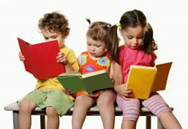  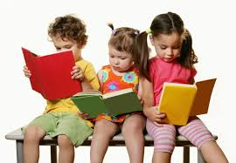 | Home Reading  Reading helps children with their knowledge, understanding and language.  The children are taught to read in school however, it is important that you encourage your child to read at home daily. Children should read at home and have their reading diary signed by an adult at least 3 times a week.  It would be very much appreciated if you would talk to your children about their Accelerated Reader target and help them to achieve it by encouraging them to read as much as possible. Prizes for outstanding readers will also be given out in class!  Reading books will be changed frequently and every week the children will have the opportunity to choose a library book to read over the weekend.  Click the video link below for tips on how to support your child with reading at home.  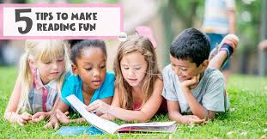  https://youtu.be/-OG2Q6pPQYw

